Multiple-choice section

|  |  |  |  |  |  |  |  |  |
| --- | --- | --- | --- | --- | --- | --- | --- | --- |
| Question | 1 | 2 | 3 | 4 | 5 | 6 | 7 | 8 |
| Answer | C | D | A | B | A | C | A | A |

Question 1 [8.1]

C

You can walk around the school and observe the number in each class.

Question 2 [8.2]

**D**

1, 2, 3, 4, 6, 8

mean =  = 4

median =  = 3.5

Question 3 [8.3]

A

 = 24.5

Question 4 [8.5]

**B**

9 balls in total, 4 of which are brown: 

Question 5 [8.5]

**A**

Four 3s have been rolled out of a total of 30 rolls.



Question 6 [8.5]

**C**

multiples of 4: 4, 8, 12, 16, 20, 24, 28

multiples of 6: 6, 12, 18, 24, 30

12 and 24 are only counted once each to give a total of 10 successful outcomes: 

Question 7 [8.7]

**A**

There are 36 outcomes possible, only one of which is the one required, so the answer is .

Question 8 [8.7]

**A**

Pr(*B* and even) =  = 

Multiple-choice total marks: 8

Short answer section

Question 9 3 marks [8.1] [8.5]

**(a)** An event for which the probability is 1 is said to be certain.

**(b)** The number of brothers and sisters you have is an example of discrete data.

**(c)** If a statistical graph is not symmetrical it is said to be skewed.

Question 10 2 marks [8.5]

The data can be considered to be continuous as every value between 52 kg and 53 kg, for example, could be attained at some point. The values that are written down are just rounded off values of potentially infinite decimal values.

Question 11 5 marks [8.2]

|  |  |  |  |  |  |  |  |  |
| --- | --- | --- | --- | --- | --- | --- | --- | --- |
| A | *x* | *f* | B | *x* | *f* | C | *x* | *f* |
|  | 30  31  32  33  34 | 3  5  10  5  3 |  | 15  16  17  18  19  20 | 10  15  8  3  1  2 |  | 48  49  50  51  52  53 | 6  5  8  14  20  10 |

**(a)** mean = median for A since the distribution is symmetrical

**(b)** B and C have the same range:

B: range = 20 – 15 = 5

C: range = 53 – 48 = 5

For A: tange = 34 – 30 = 4

**(c)** B has a positive skew (tail to the right).

|  |  |  |
| --- | --- | --- |
| *x* | *f* | *x* × *f* |
| 15  16  17  18  19  20 | 10  15  8  3  1  2 | 150  240  136  54  19  40 |
| Total | 39 | 639 |

mean =  ≈ 16.4

median: 19th datum = 16

Question 12 7 marks [8.3]

**(a)**

|  |  |  |  |
| --- | --- | --- | --- |
| Distance (m) | Frequency | Midpoint | *xf* |
| 0−<10 | 4 | 5 | 20 |
| 10−<20 | 12 | 15 | 180 |
| 20−<30 | 24 | 25 | 600 |
| 30−<40 | 9 | 35 | 315 |
| 40−<50 | 1 | 45 | 45 |
|  | Σ*f* = 50 |  | Σ*xf* = 1160 |

mean =  = 23.2 m

**(b)**

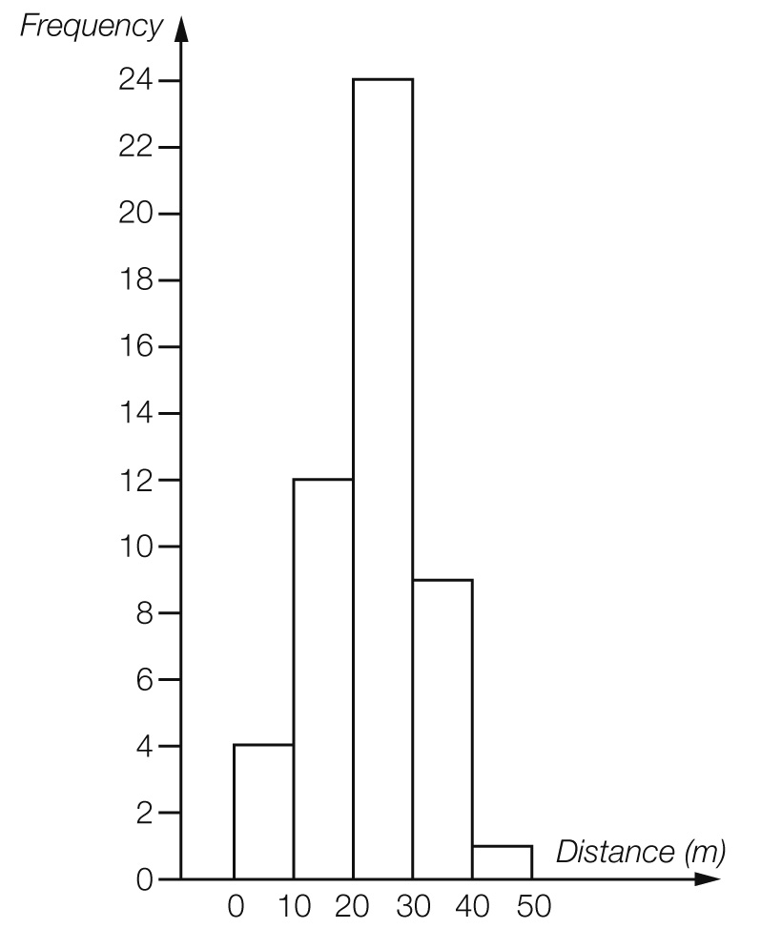

The large number of values in the middle band makes this data relatively symmetrical.

Question 13 2 marks [8.5]

**(a)** Pr(Rhonda wins) =  = 40%

**(b)**  × 8 = 4.8

Michelle would expect to win 5 games.

Question 14 3 marks [8.5]

**(a)** Pr(neither red nor pink) =  =  = 

**(b)**  × 8 = 2.5

2 or 3 lollies are expected to be pink or brown.

Question 15 7 marks [8.6]

**(a)** **(i)** *A* and *B* are mutually exclusive.

**(ii)** *A* and *C* are not mutually exclusive.

**(iii)** *A* and *D* are not mutually exclusive.

**(b) (i)** Pr(*B* and *C*) = Pr(b, c, d, f) =  = 

**(ii)** Pr(*C* or *D*) =  = 

**(iii)** Pr(*A* and *B*) = 0

**(iv)** Pr(*B* only) =  = 

Question 16 8 marks [8.7]

(a)

|  |  |  |  |  |  |  |  |  |  |
| --- | --- | --- | --- | --- | --- | --- | --- | --- | --- |
|  | R1 | R2 | R3 | Y1 | Y2 | B1 | B2 | B3 | B4 |
| R1 |  | RR | RR | RY | RY | RB | RB | RB | RB |
| R2 | RR |  | RR | RY | RY | RB | RB | RB | RB |
| R3 | RR | RR |  | RY | RY | RB | RB | RB | RB |
| Y1 | YR | YR | YR |  | YY | YB | YB | YB | YB |
| Y2 | YR | YR | YR | YY |  | YB | YB | YB | YB |
| B1 | BR | BR | BR | BY | BY |  | BB | BB | BB |
| B2 | BR | BR | BR | BY | BY | BB |  | BB | BB |
| B3 | BR | BR | BR | BY | BY | BB | BB |  | BB |
| B4 | BR | BR | BR | BY | BY | BB | BB | BB |  |

**(b)** Pr(RR) = 

**(c)** Pr(RR, YY or BB) = 

**(d)** Pr(neither blue) = 

**(e)** Pr(BY or YB) = 

Question 17 15 marks [8.3]

**(a)** This data set has negative skew since the mean has been pulled to the left.

**(b)** To give a mean of 32 from 16 scores, the total must be 512.

A sample answer:

Put 37 and 38 in the middle two positions, to achieve a median of 37.5. There must be more 41s than any other score.

e.g. 18, 20, 22, 23, 24, 25, 26, 37, 38, 38, 39, 39, 40, 41, 41, 41

Short answer total marks: 37

Extended answer section

Question 18 15 marks [8.4]

**(a)** NSW: mean =  = 164.2 cm

Victoria: mean =  = 167.8 cm

**(b)**

|  |  |  |
| --- | --- | --- |
| NSW Year 9 students |  | Victoria Year 9 students |
| 6 | 12 |  |
|  | 13 |  |
| 8 6 2 | 14 |  |
| 6 5 2 2 0 | 15 | 7 9 |
| 7 7 6 4 4 4 2 0 0 | 16 | 0 0 1 1 2 2 4 4 5 5 5 6 6 7 7 7 7 7 8 |
| 9 9 6 5 4 4 3 2 0 | 17 | 2 4 4 5 5 7 8 |
| 8 2 2 | 18 | 2 6 |

**(c)** NSW: median = 165 cm and range = 188 – 126 = 62 cm

Victoria: median = 166.5 cm and range = 186 – 157 = 29 cm

**(d)** Although the mean and median are close for the two different states the range of heights is quite different. The 9 shortest students come from NSW as does the tallest.

**(e)** Estimated mean:  = 166.0 cm

Estimated median: = 166 cm

Range of sample of 60: 188 – 126 = 62 cm so population range is almost certain to be higher, say 70 cm, unless the tallest and shortest Year 9 students in both states just happened to be in this sample.

Assume that the samples are random and hence mean and median of samples is the best predictor of population averages. It is assumed that equal numbers of Year 9 students in each state which is unlikely. The limitation is that this will only predict population statistics for the same time of year as the data was gathered as a portion of Year 9 students will grow throughout the year.

Question 19 8 marks [8.6]

(a)

|  |  |  |  |
| --- | --- | --- | --- |
|  | TV in bedroom | No TV |  |
| Ride bicycle | 2 | 8 | 10 |
| No riding | 5 | 7 | 12 |
|  | 7 | 15 | 22 |

(b)

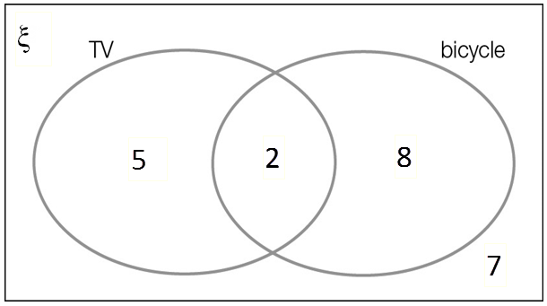

**(c)** **(i)** Pr(TV) = 

**(ii)** Pr(TV and bicycle) =  = 

**(iii)** Pr(no bicycle riding) =  = 

**(d)** Pr(TV knowing bicycle riding) =  = 

Question 20 14 marks [8.5]

**(a)** mean =  ≈ 40.0 runs

0, 0 , 1, 7, 9, 12, 13, 14, 21, 21, 21 | 23, 24, 26, 37, 38, 54, 56, 65, 121, 144, 174

median = 22 runs

range = 174 – 0 = 174 runs

**(b)** Pr(score is under 10) =  × 100% ≈ 23%

**(c)** Without scores under 10: mean =  ≈ 50.8 runs

**(d)** **(i)** Pr(at least 50) = × 100% ≈ 27%

**(ii)** Pr(at least 100) = × 100% ≈ 14%

**(e)** Pr(100 once 50 is reached) = × 100% = 50%

Extended answer total marks: 37

TOTAL test marks: 87